Lab 6

18. Logic Circuits

Andrea Tuggle

05/02/2019

Physics II

Dr. Harrison

1. OBJECTIVE

In this lab we are creating different forms of gates by creating circuits with a breadboard, resistors, gates, etc. By creating these we will see different connections through the AND, OR, NOT gates.

1. DATA

AND Gate:

(A) 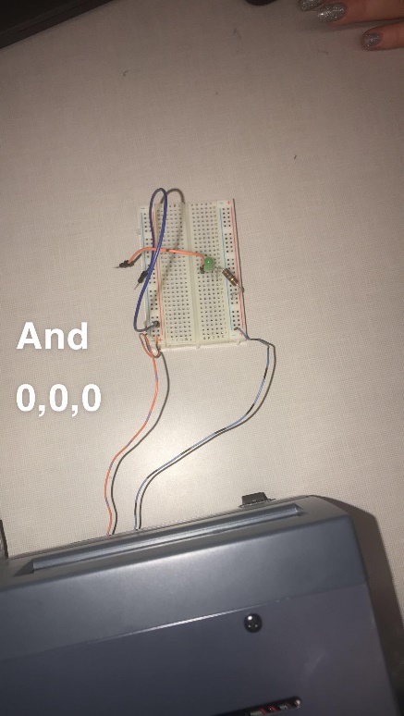(B)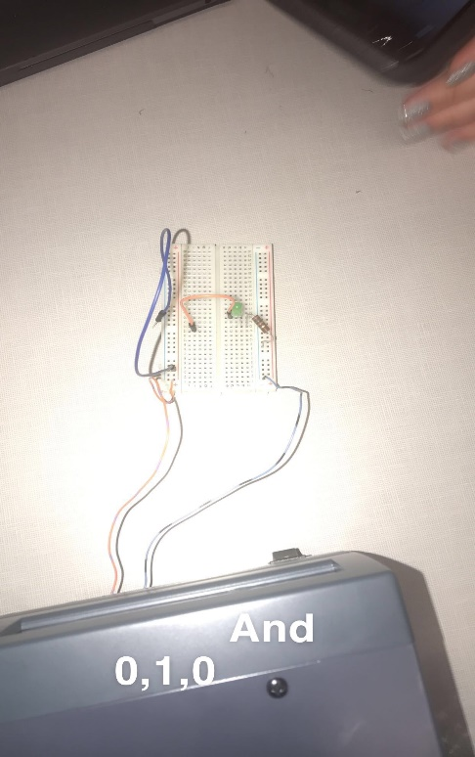

(C) 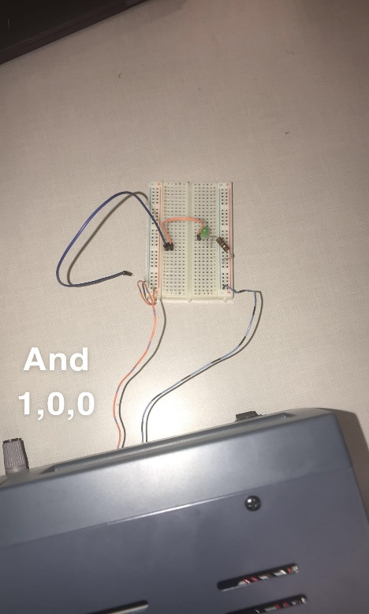(D)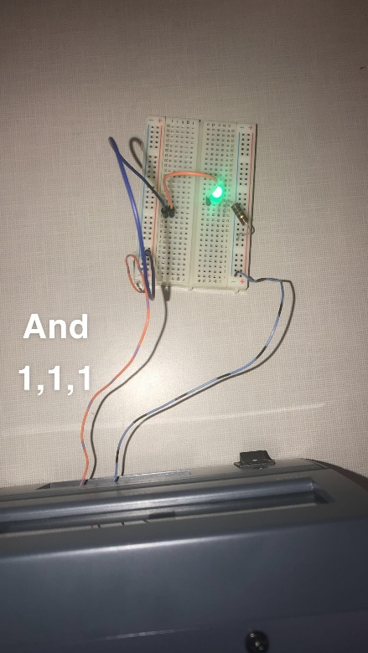

OR Gate:

(A) 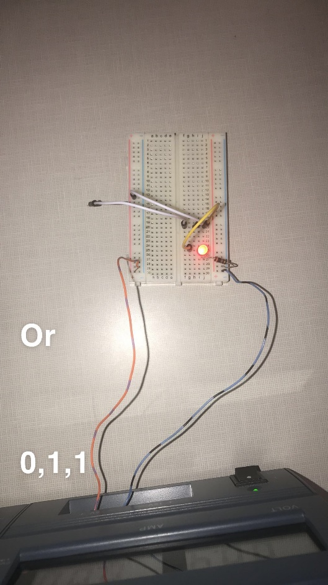(B)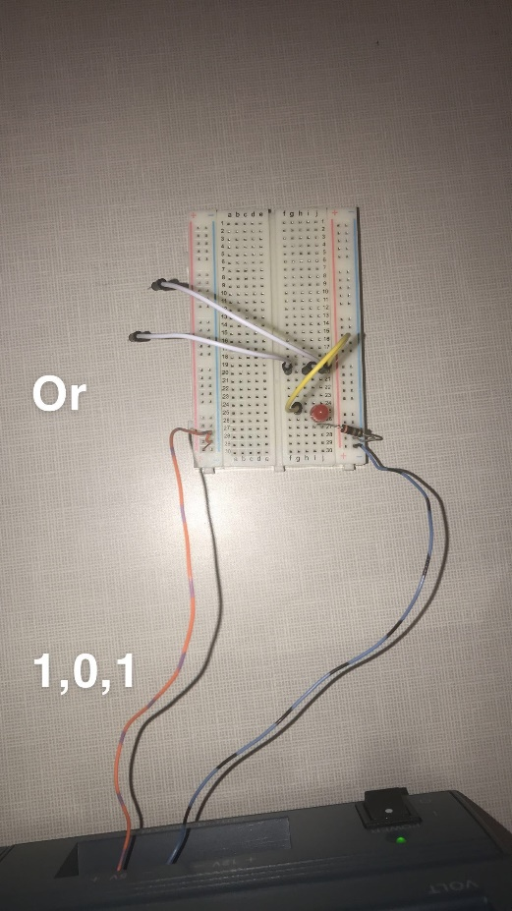

(C)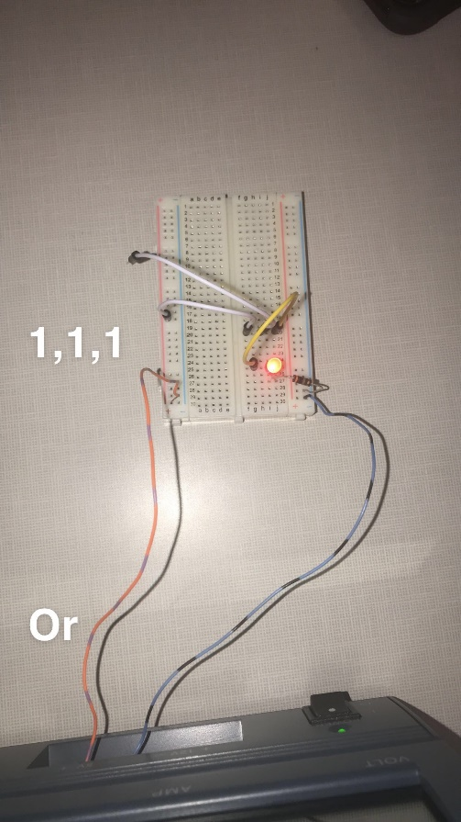

NOT Gate:

(A)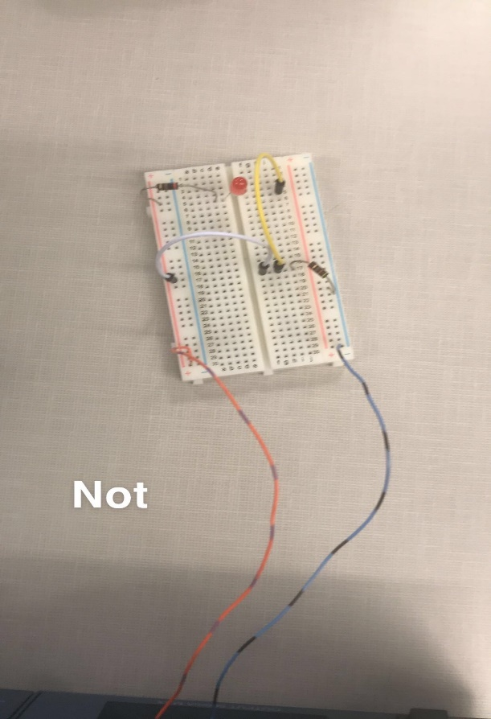 (B)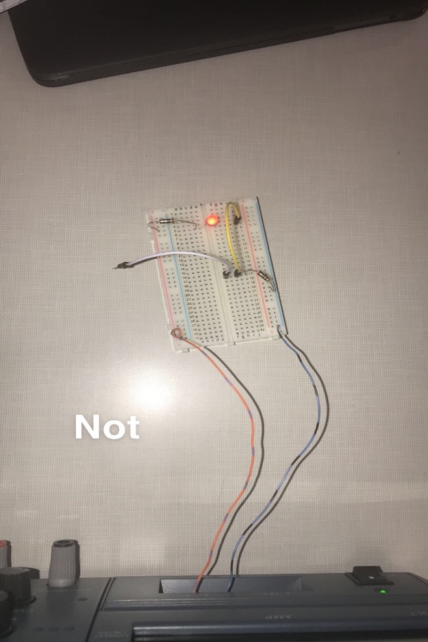

1. CALCULATIONS

AND Gate:

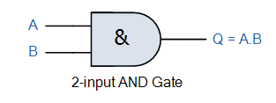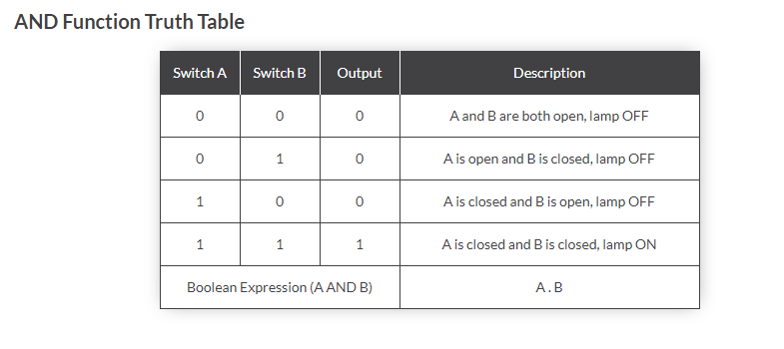

OR Gate:

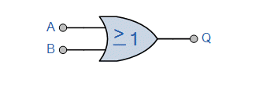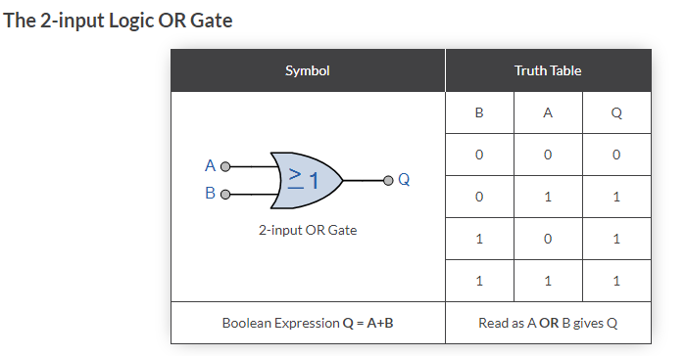

NOT Gate:

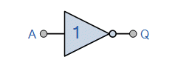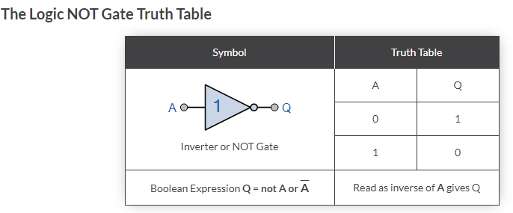

1. RESULTS

AND GATE: In the AND GATE (A) you can see that A and B are both open which resulted in the lamp not being on. In the AND GATE (B) you can see that A is open and B is closed, resulting in the lamp still not being on. In the AND GATE (C) you can see that that A is closed and B is open, still resulting in the lamp being off. But in the AND GATE (D) you can see that both A and B are both closed resulting in the lamp being on. As a result, both switch A and switch B must be closed in order to put the lamp on.

In NOT GATE (A) you can see that the circuit is closed and the resistor bulb is not lit. In NOT Gate (B) you can see that the circuit is broken and yet the resistor bulb is lit. A NOT Gate only has a single input with a simple behavior which is logical negation. If the input is true, then the output will be false and vice versa if the input is false, then the output will be true.